**Section- A**

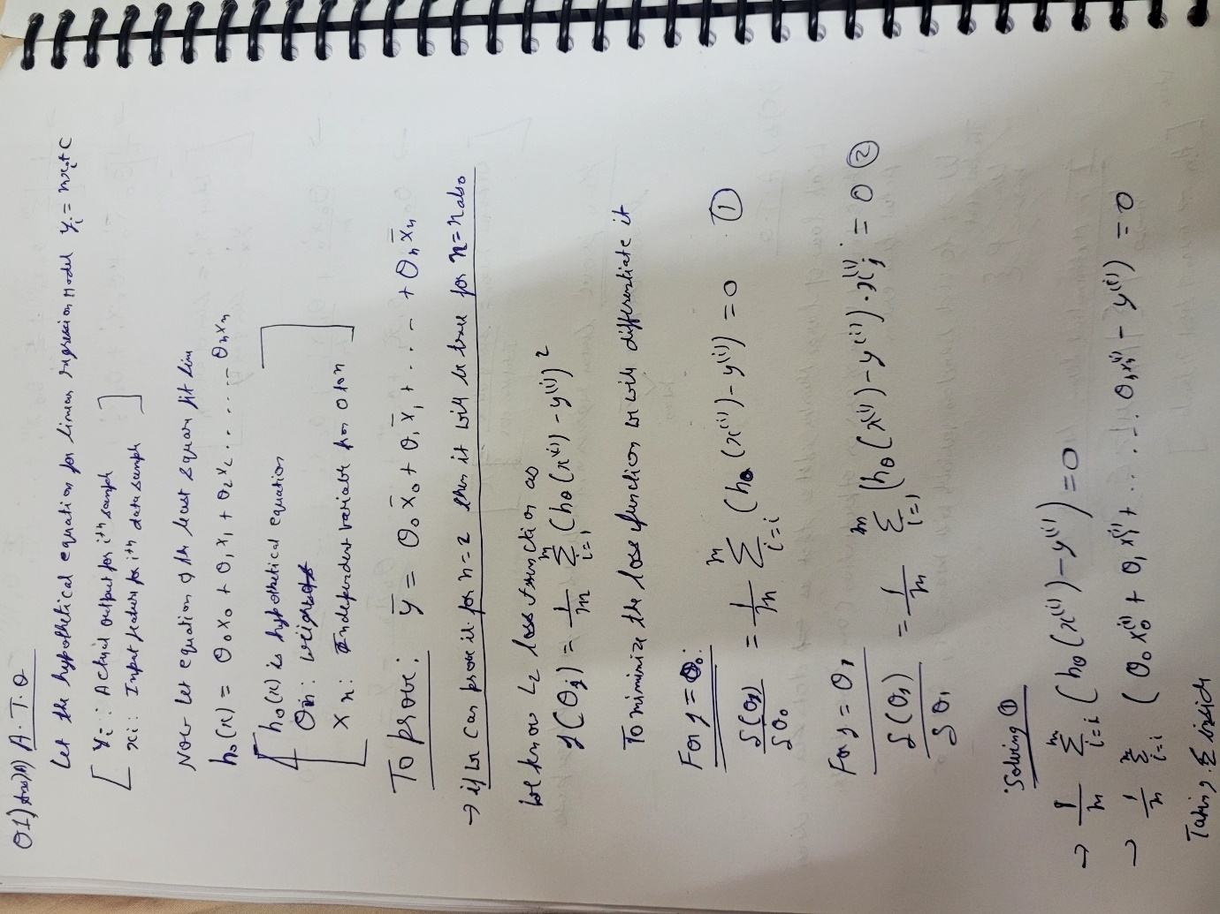

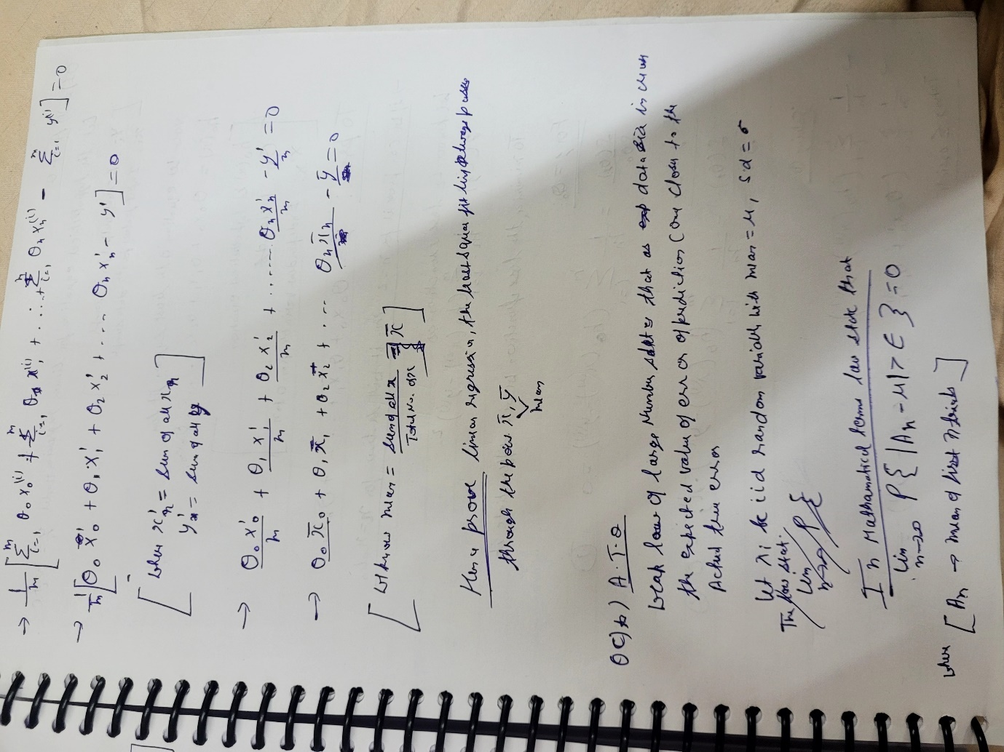

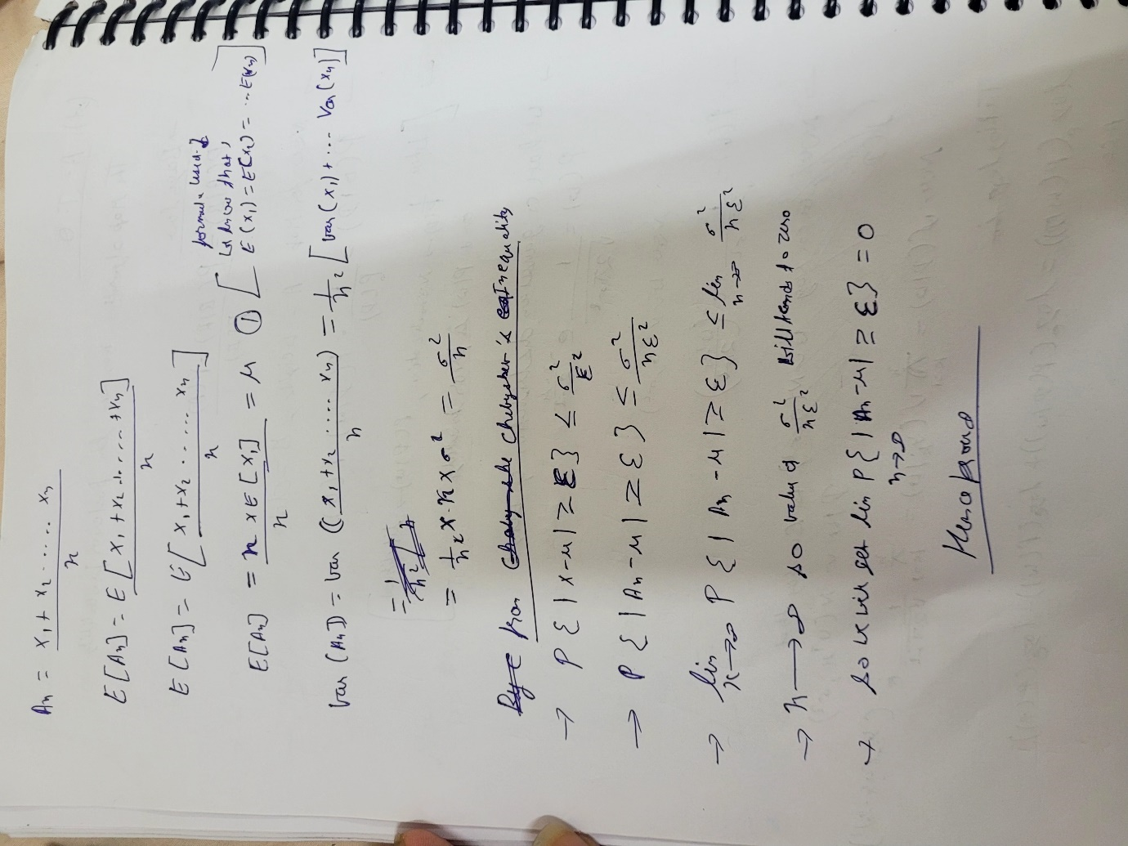

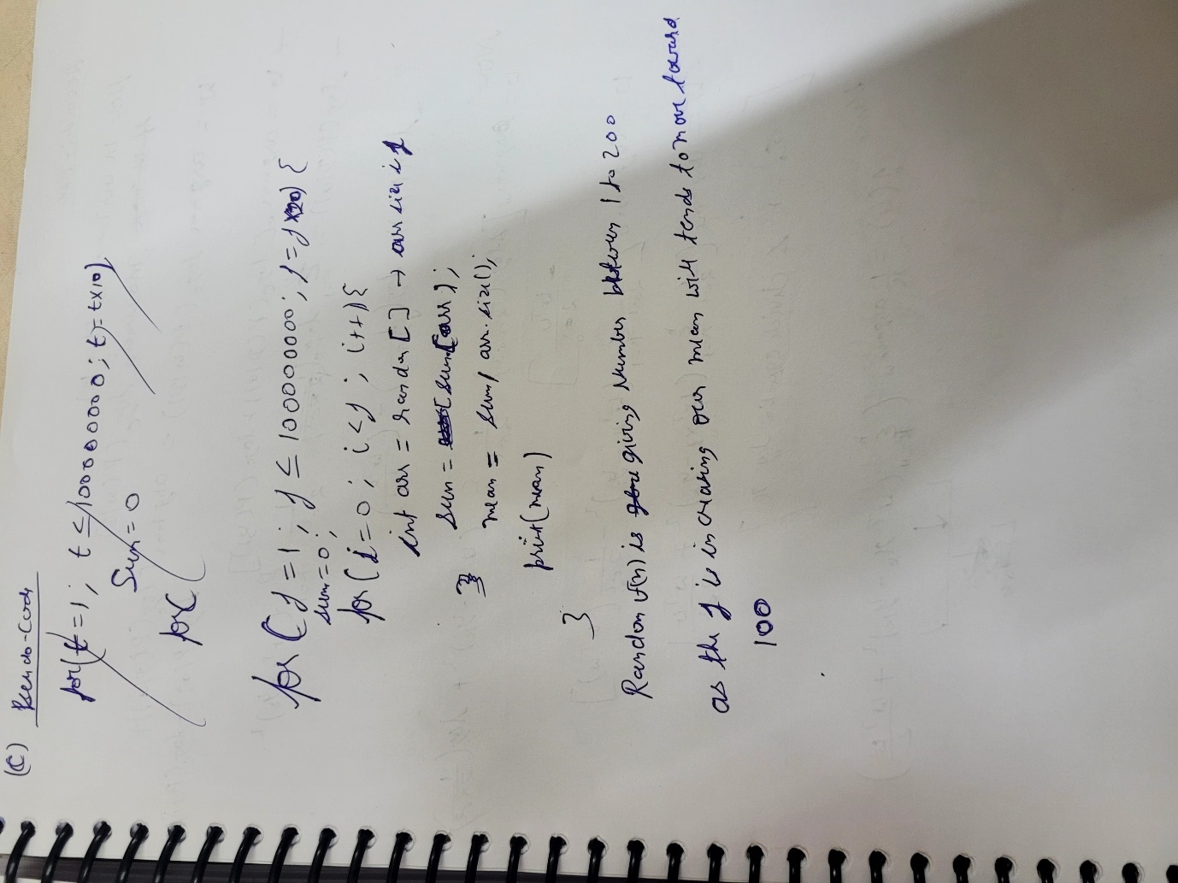

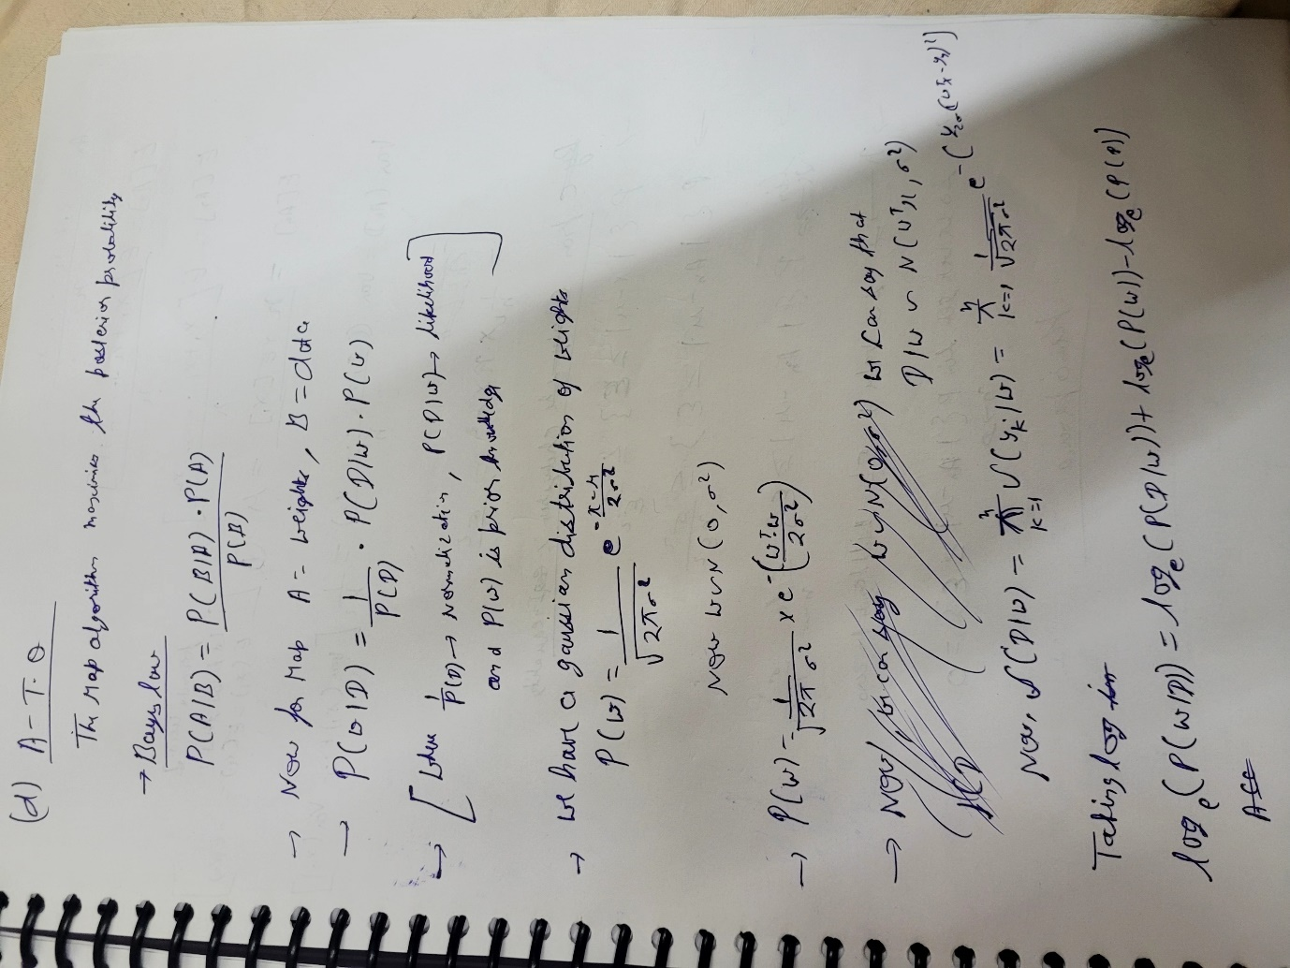

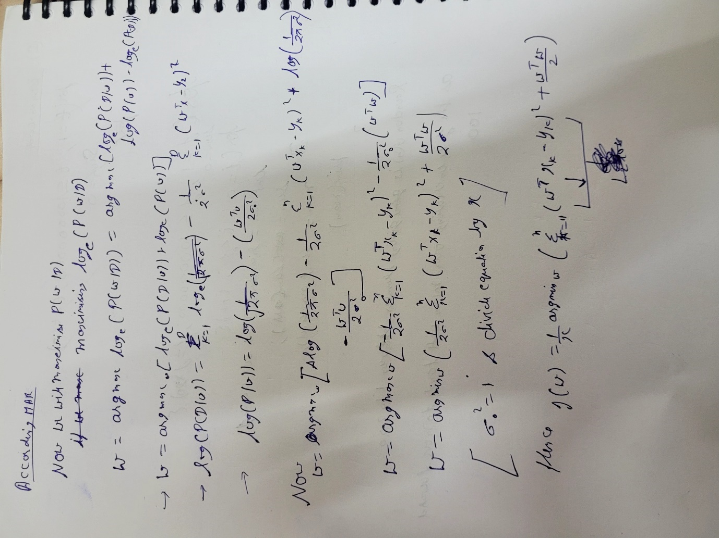

**Answer B)**

**Lets take A = x , B = Y where x and y have range of real numbers**

**Z = A*B here we can see that Z have a strong correlation with A and B, as any one of them changes value of Z will change.**

**If A changes value of Z will change and similarly if B changes value of Z will change**

**But change in value of A doesn’t change value of B so A and B have no correlation with each other same.**

**Section- B**

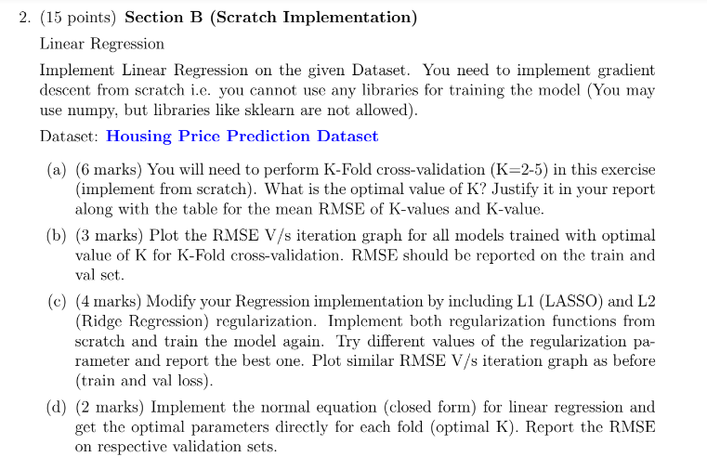



**DATA pre-processing:**

In the given dataset we check for if there is any null value and then we scaled the entire data.

Scaling formula used here : 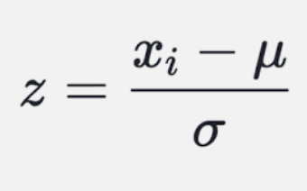

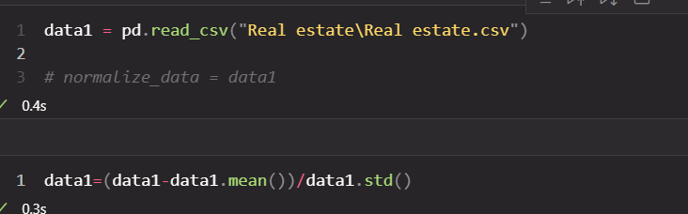

We have also dropped the column ‘No’ from the data.



**Implement Gradient Descent from scratch:**

All formulas:

*Cost function:* J(Ɵ)=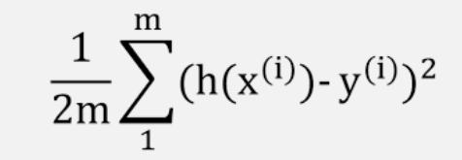

Ɵ0,Ɵ1,………,Ɵn  - weights

m : Total number of data samples

x(i): Input features for the ith data sample.

h(x(i)): hypothesis

y(i): Actual output for ith data sample

*Algorithm:*

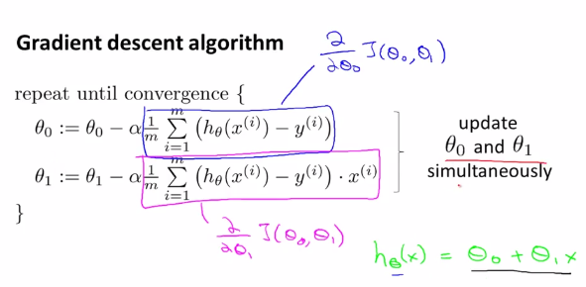

*Code:*

*Side functions:*

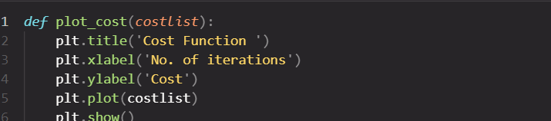

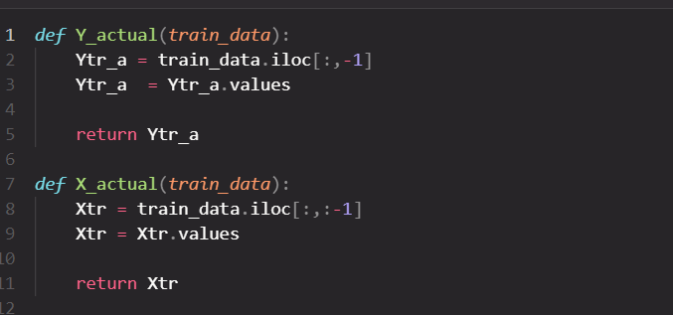

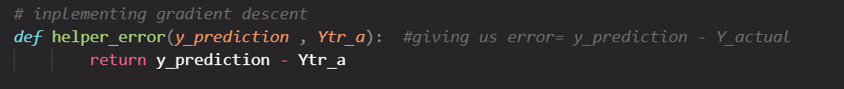

Main function:

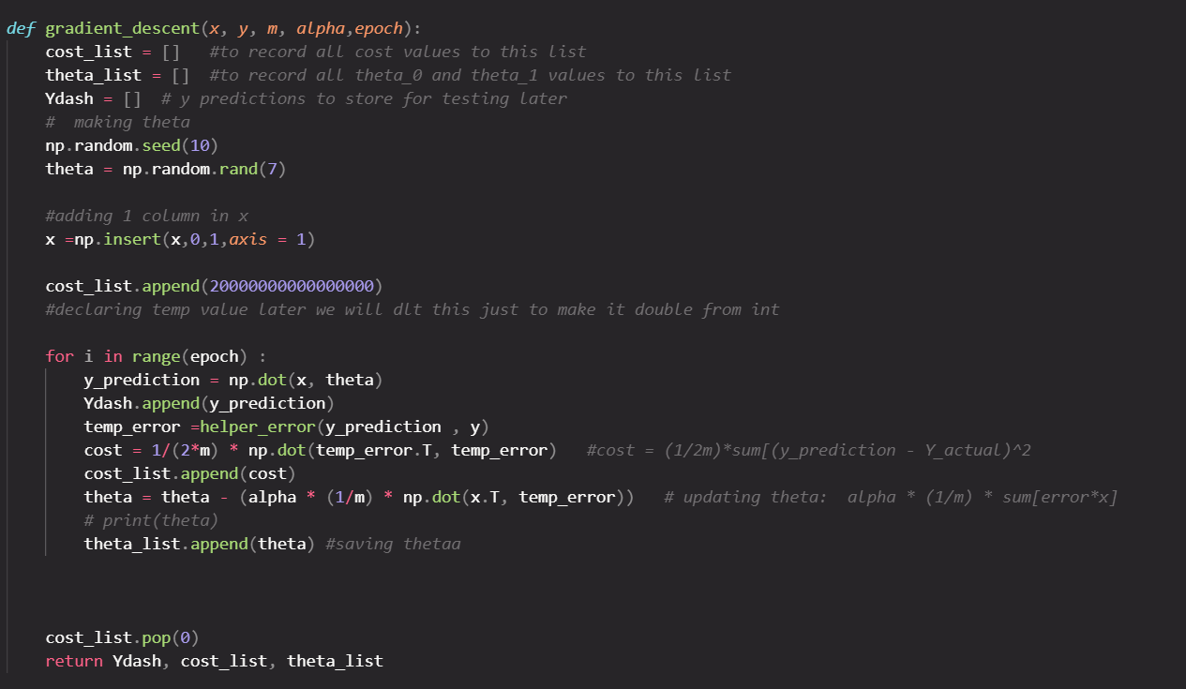

*Theta : weight of model*

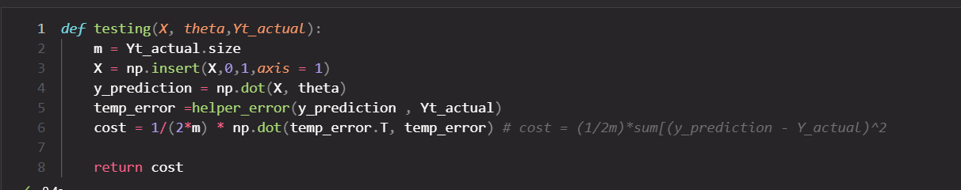

We have initialized all the theta for the time randomly, then updating theta in every epoch

* ***We have also Calculated the testing and training error for our model***



Alpha = 0.0035

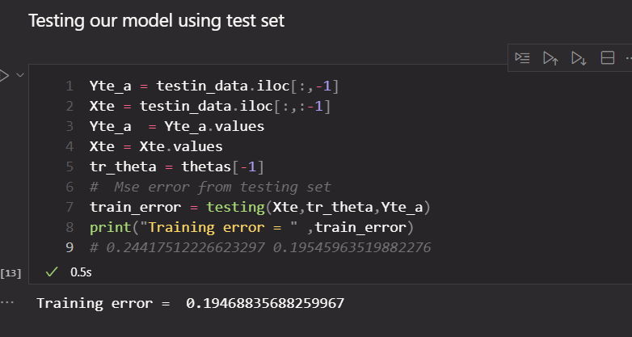

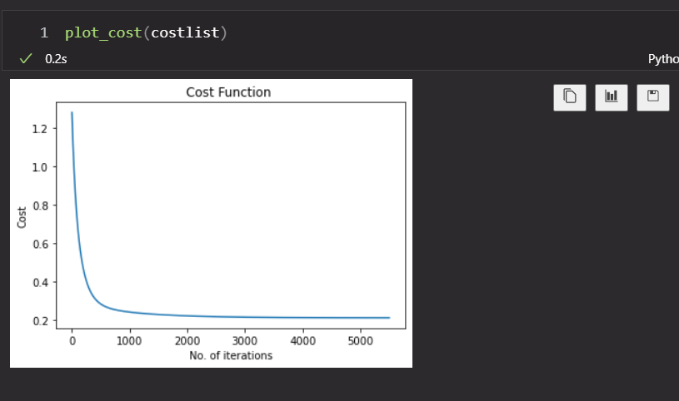

Part A)

First we have randomised the data sample

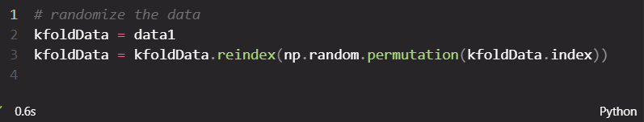



Then we have done K-fold cross validation according to given question:

First we divided the data into K parts (K =5,4,3,2) and for every K we have made Train(n) set and Test(m) set {where n = k-1 and m =K-n}

Then we have Trained our model with the help of gradient descent on the Train set for every n and tested the model on Test set. We have then calculated the Root mean square error(rmse) with help of train model weights.

Rmse for all K-values

*Table: K_value vs Mean Rmse*

|  |  |
| --- | --- |
| K-value | Mean Rmse |
| 5 | |  |  | | --- | --- | | Fold 1 | 0.598533 | | Fold 2 | 0.543886 | | Fold 3 | 0.567571 | | Fold 4 | 0.535383 | | Fold 5 | 0.937109 |   Mean:0.636797 |
| 4 | |  |  | | --- | --- | | Fold 1 | 0.628975 | | Fold 2 | 0.511595 | | Fold 3 | 0.535202 | | Fold 4 | 0.870449 |   Mean:0.636555 |
| 3 | |  |  | | --- | --- | | Fold 1 | 0.597461 | | Fold 2 | 0.549705 | | Fold 3 | 0.788908 |   Mean:0.6453584 |
| 2 | |  |  | | --- | --- | | Fold 1 | 0.5915280 | | Fold 2 | 0.7233616 |   0.651257 |

The optimal K-value is **K =4** that is **0.63655**

**Code:**

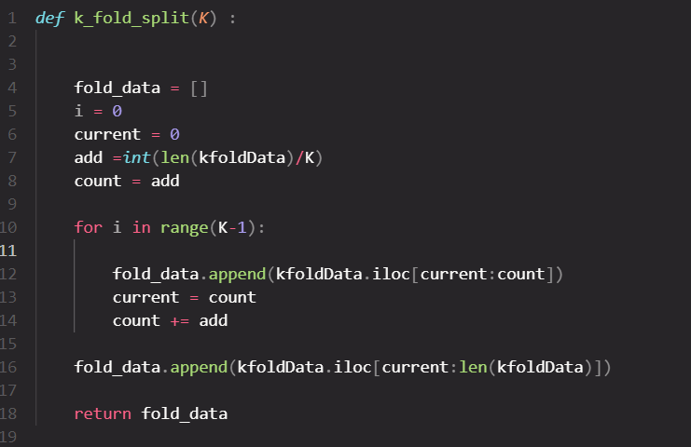

*Showing output code for Best Kmean:*

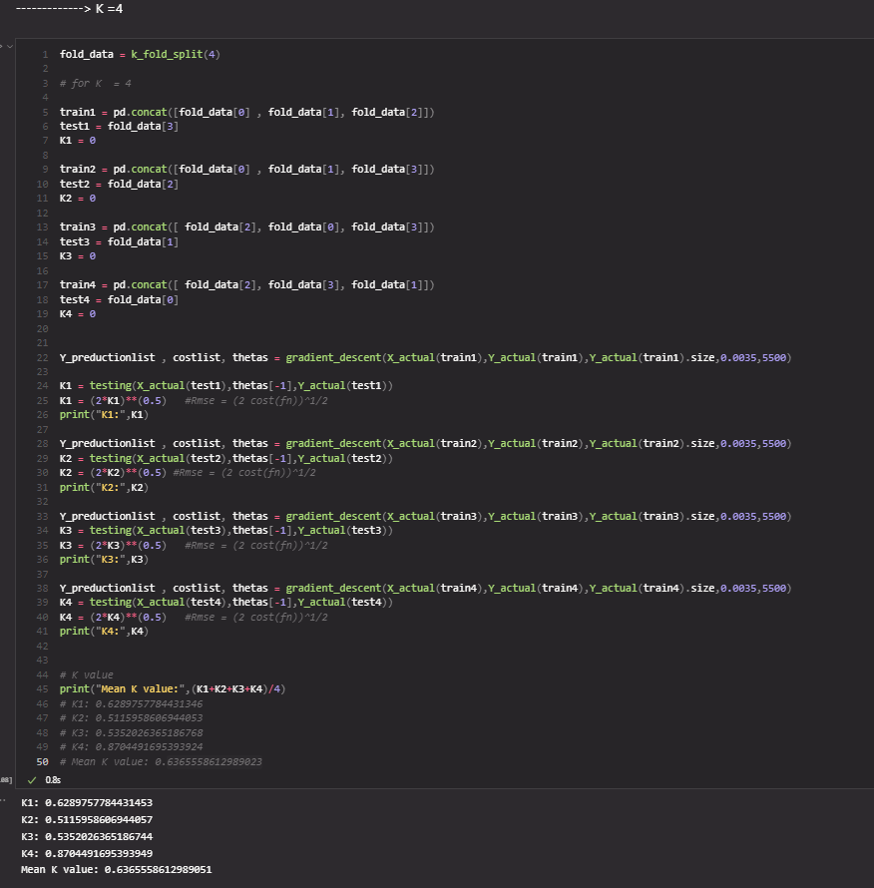

PART **B**

*RMSE vs Iteration graph for all models trained with optimal value of K=4 for K-fold*

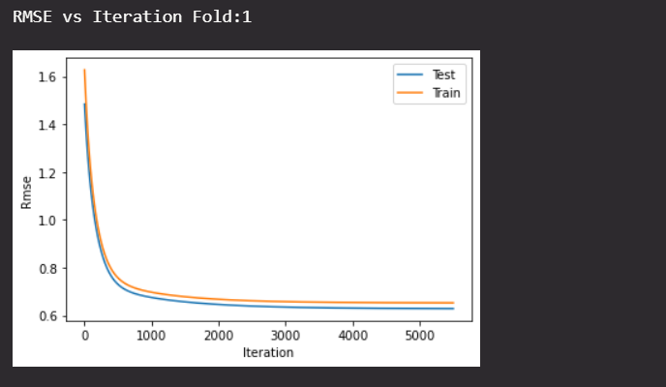

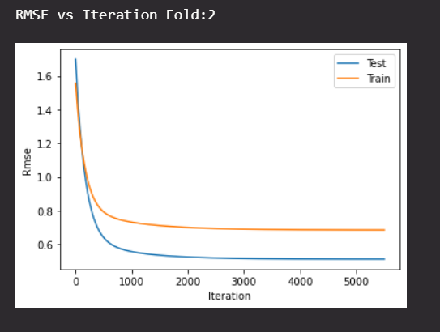

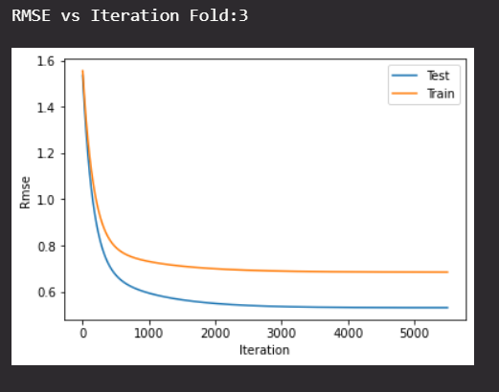

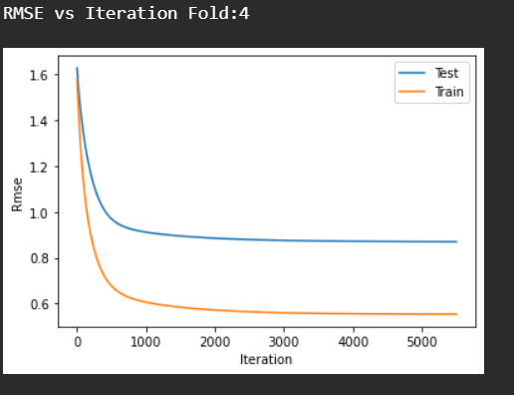

PART :**C**

L1 regularization:

*Formula used:*

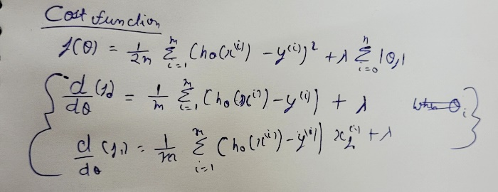

Updating Ɵj (way to update the theta inside code for L1)

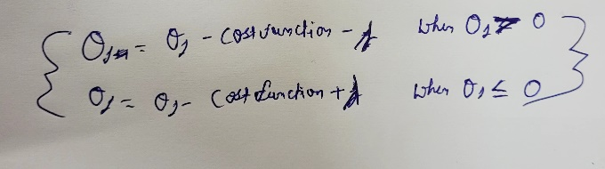

**Code**

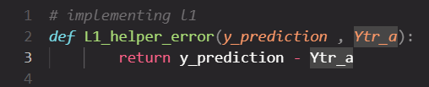

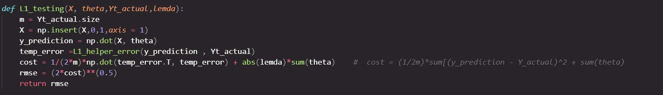

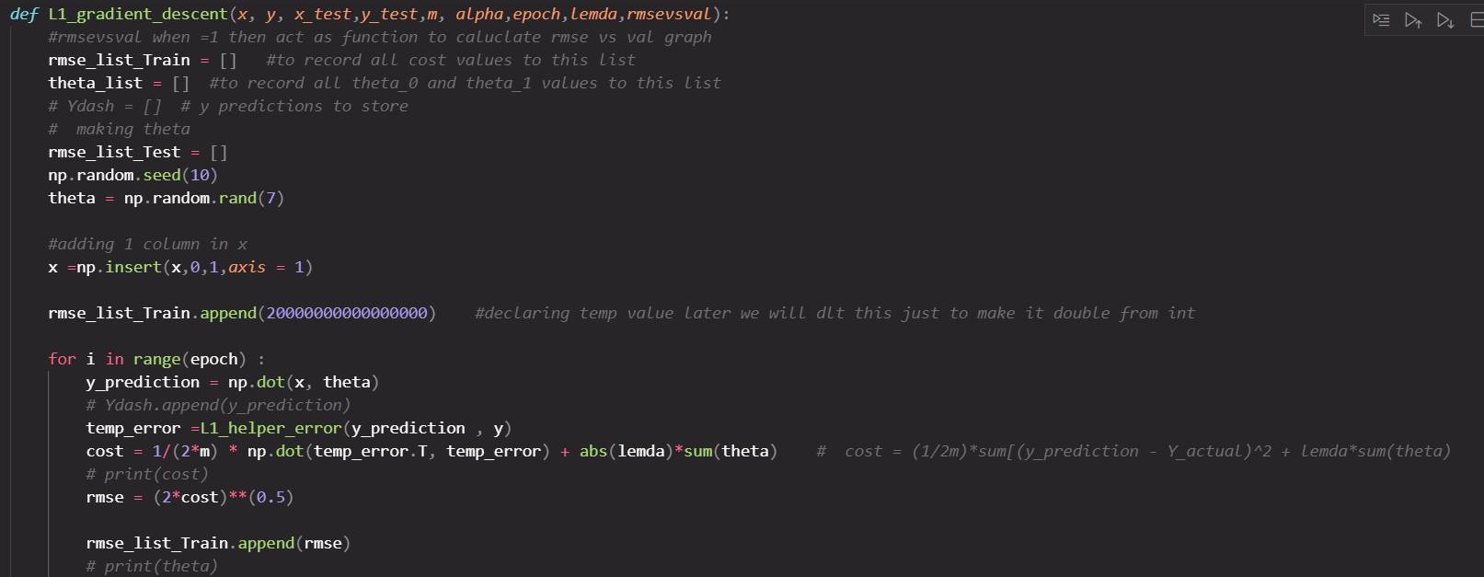

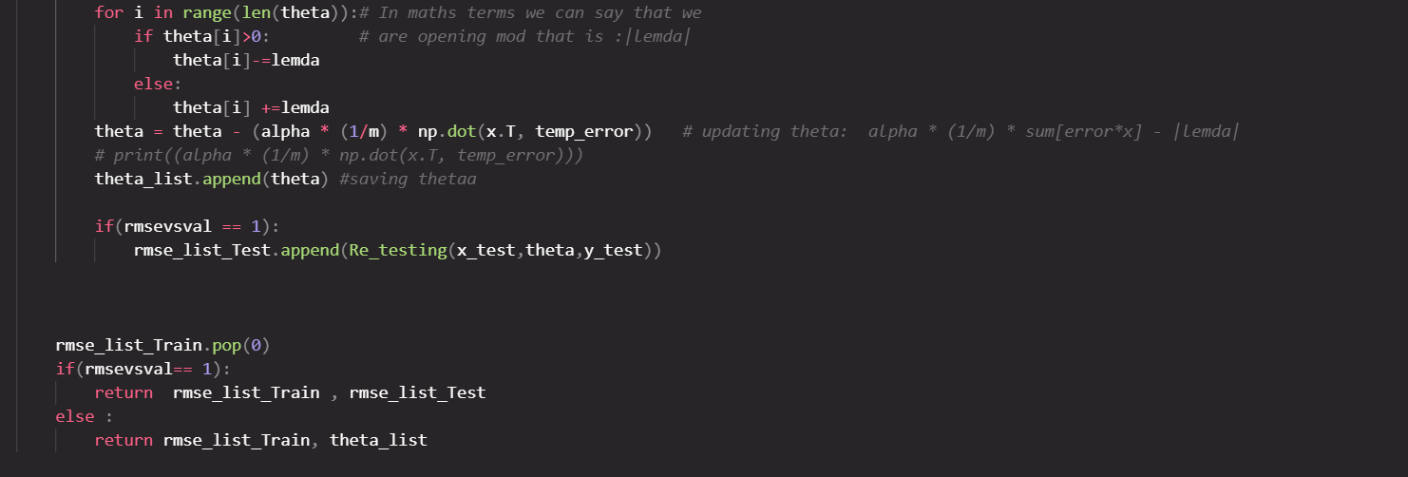

Different values of lambda vs Mean RMSE:

**Table:**

|  |  |
| --- | --- |
| **Lambda** | **Mean Rmse** |
| 0.1 | 0.9516836 |
| 0.001 | 0.7142055 |
| 0.0001 | 0.625595 |
| 0.000051 | 0.6261506 |
| 0.0000059 | 0.6285677 |
| 0.00000069 | 0.6289269 |

*K-Fold Cross Validation Method with K = 4 and Lambda =* 0.0001

Graph :

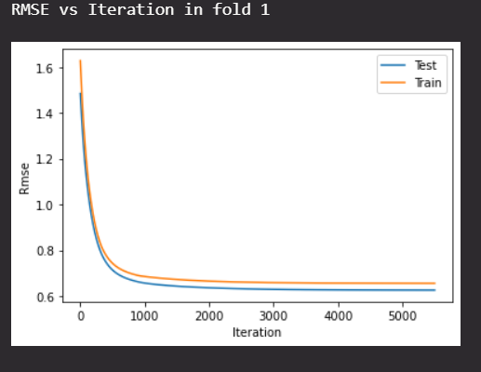

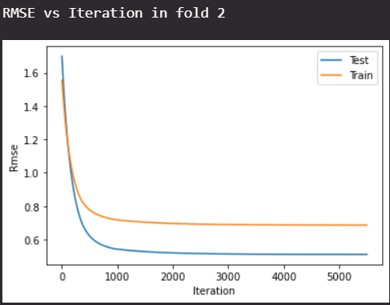

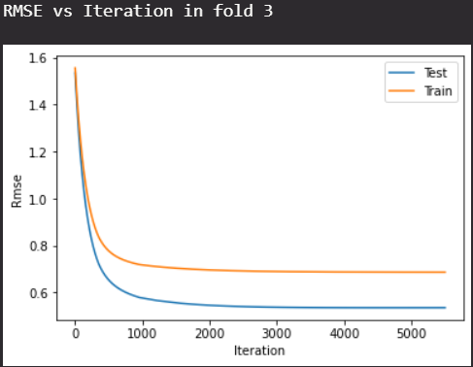

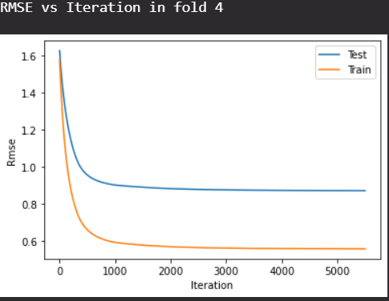

Code for K = 4 and lambda = 0.0001

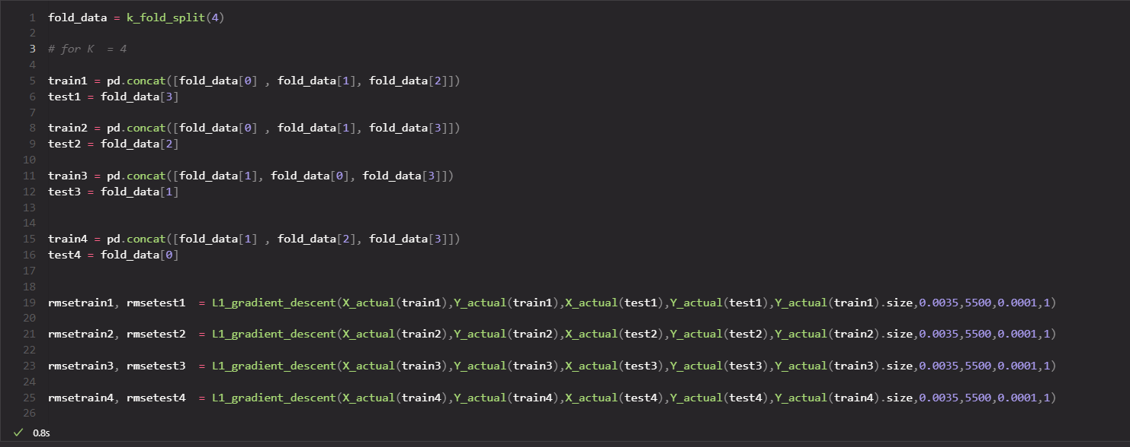

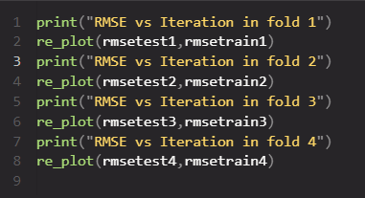

**L2 regulaeization(Ridge regression)**

Formulas used:

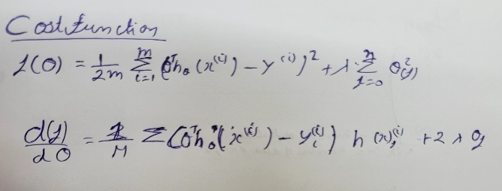

Code:

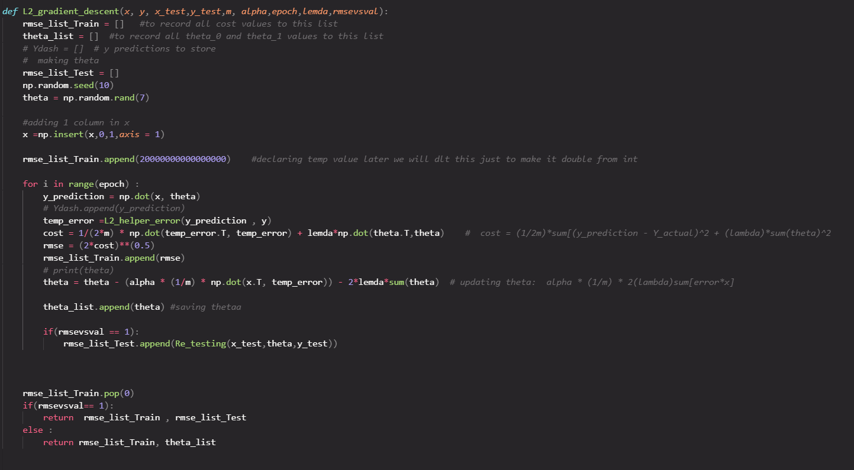

Different values of lambda vs Mean RMSE:

|  |  |
| --- | --- |
| **Lambda** | **Mean Rmse** |
| 0.1 | 0.8888019 |
| 0.001 | 0.7704632 |
| 0.0001 | 0.6275338 |
| 0.000051 | 0.62808050 |
| 0.0000059 | 0.62885283 |
| 0.00000069 | 0.62885283 |

Best value of lamda for L2(**Ridge regression**) is 0.0001

L2 plot Rmse V/s iteration for K =4

Code:

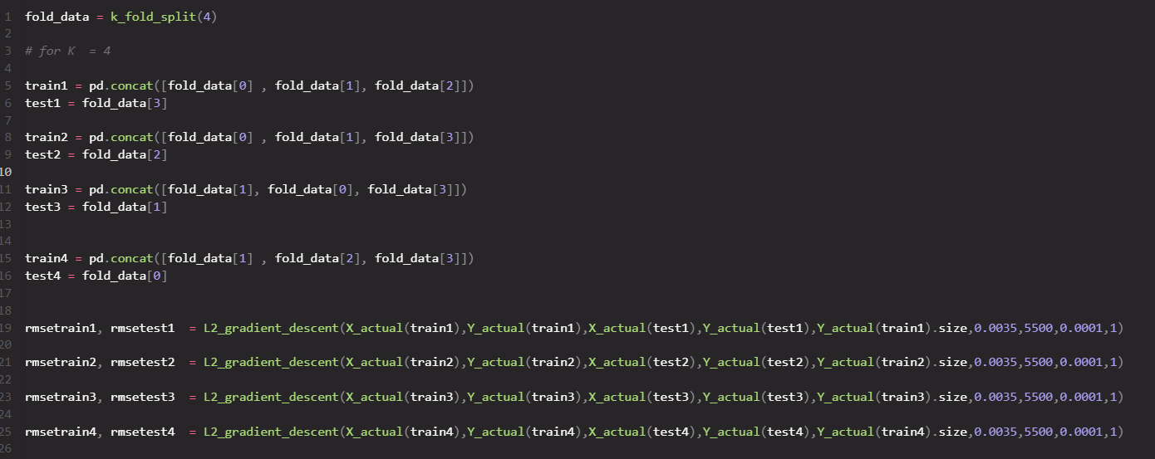

Graph:

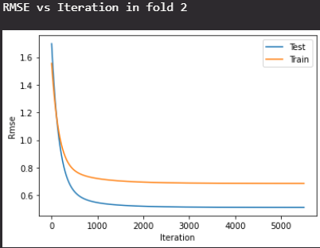

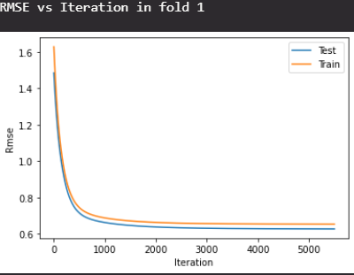

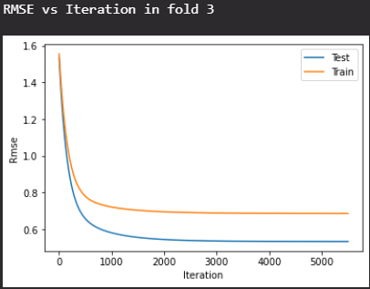

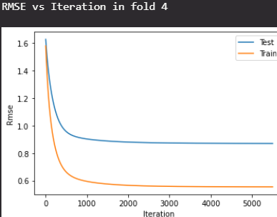

PART :**D**

*Normal equation :*

**Ɵ =(XTX)-1.( XTY)**

*Code:*

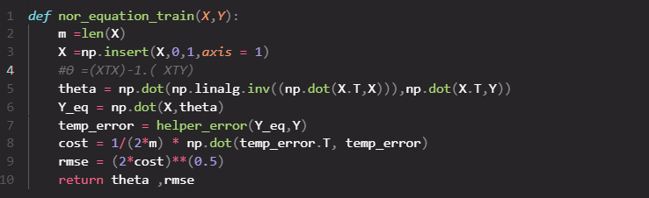

As we know optimal value of K=4

Training our model for K=4

Table for K-value vs RMSE

|  |  |  |
| --- | --- | --- |
| **Fold no.** | **Optimal parameters** | RMSE |
| 1 | |  |  | | --- | --- | | *Parameter* | *Value* | | Ɵ0 | 0.0207766 | | Ɵ1 | 0.0877178 | | Ɵ2 | -0.2477262 | | Ɵ3 | -.04113045 | | Ɵ4 | 0.23591649 | | Ɵ5 | 0.22846858 | | Ɵ6 | -0.0130103 | | 0.627966 |
| 2 | |  |  | | --- | --- | | *Parameter* | *Value* | | Ɵ0 | -2.8157*e-4 | | Ɵ1 | 0.011904 | | Ɵ2 | -0.22159 | | Ɵ3 | -0.42743 | | Ɵ4 | 0.22803 | | Ɵ5 | 0.20452 | | Ɵ6 | 0.002188 | | 0.511711 |
| 3 | |  |  | | --- | --- | | *Parameter* | *Value* | | Ɵ0 | -2.8157e-4 | | Ɵ1 | 0.19404 | | Ɵ2 | 0.22159 | | Ɵ3 | -0.42743 | | Ɵ4 | 0.22802 | | Ɵ5 | 0.20452 | | Ɵ6 | 2.18820e-3 | | 0.5320325 |
| 4 | |  |  | | --- | --- | | *Parameter* | *Value* | | Ɵ0 | -0.01102 | | Ɵ1 | 0.114846 | | Ɵ2 | -0.234727 | | Ɵ3 | 0.3940832 | | Ɵ4 | 0.2766535 | | Ɵ5 | 0.1821304 | | Ɵ6 | -0.019418 | | 0.8691125 |

**SECTION – C**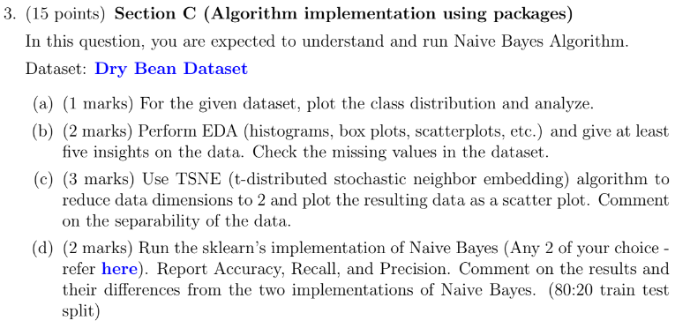

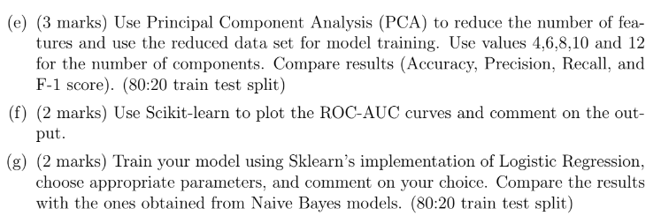

Checking for any missing value In data or NA values

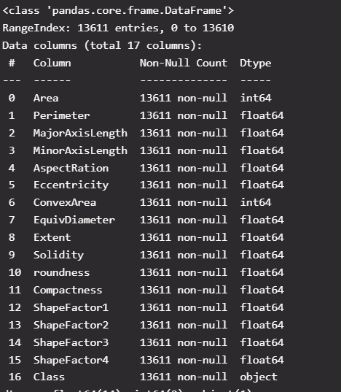

PART :**A**

Class distribution:

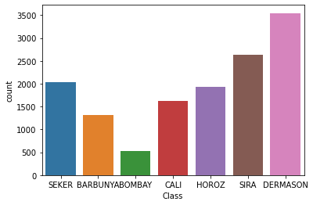

*Analysis*

From the above plot, we can say that :

1. Our data set classified dry beans into seven parts based on different features. Therefore it is multi-class classification
2. The Dermason dry bean has the highest count, meaning it has more sample data in the entire data set.
3. The Bombay dry bean has the lowest count, meaning it has least sample data in the entire data set

PART :**B**

1. **Scatter plot:**

Code: 

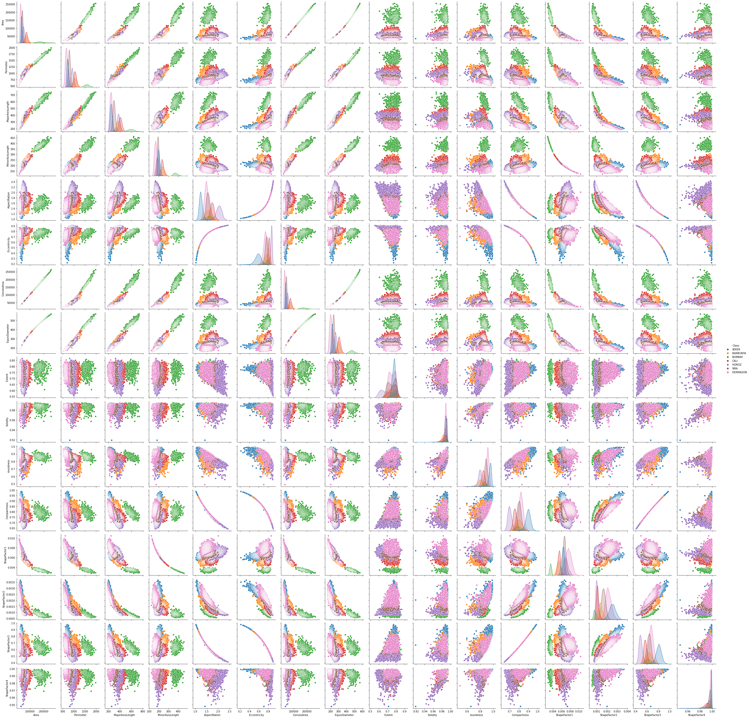

1. **Box plots:**

Code:

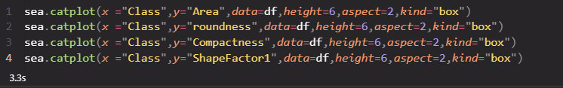

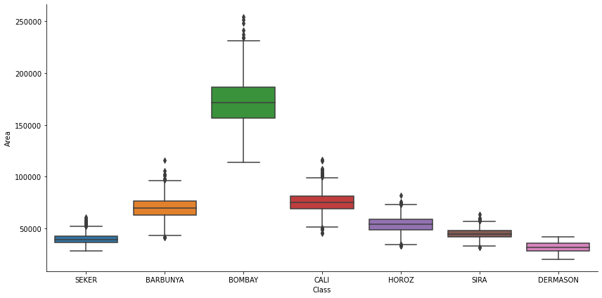

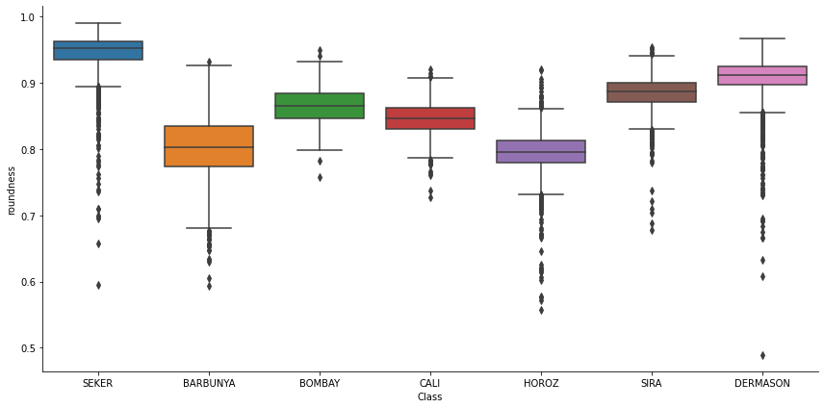

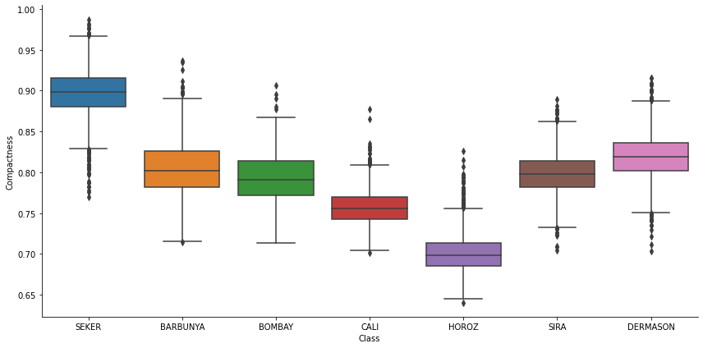

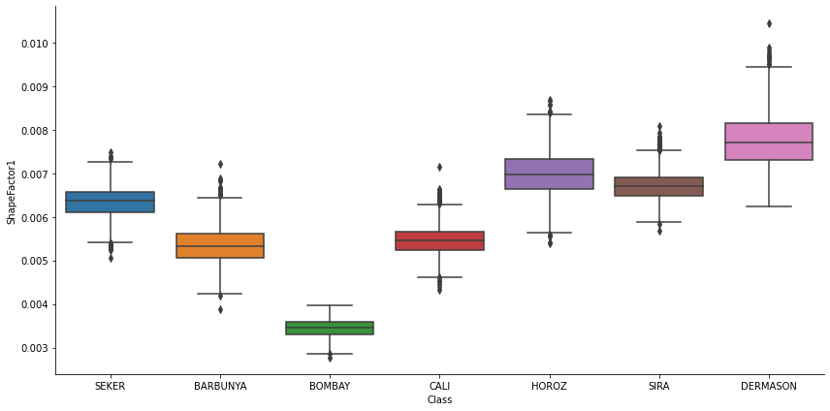

1. **Corelation map**

Code: 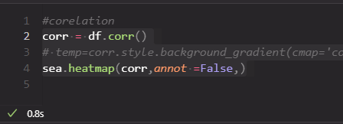

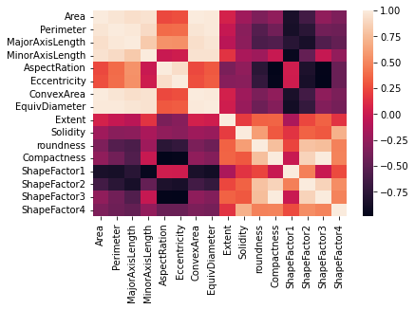

**Insights from the data:**

* Using Boxplot, we tell about the distribution of data set, variance, and outliers of features in our data.

1. Area , perimeter, MajorAxislength, MinorAxisLength has identical distribution
2. Eccentricity,Solidity,Roundness have higher number of outliers

* Using scatter plot:

1. Shape factor 2 and major axis length are hyperbolic functions in nature only in positive x and y axis.
2. Perimeter and major axis length have linear relationship
3. We also know the density distribution.

* Area, convex have very high positive correlation with each other.
* Minor axis length and shape factor1 have very high negative correlation

PART :**C**

First we have done data processing

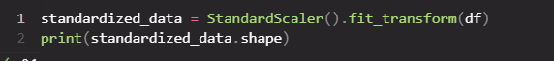

Code:

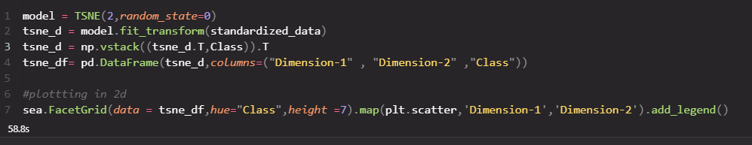

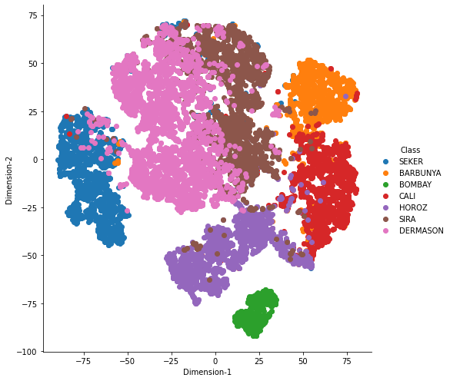

**Comment on the separability of the data.**

From the above plot, we can say:

* BOMBAY class have low correlation and no data is overlapping with other classes
* DERMANSON and Sira class have high correlation
* Cali class have many outliers as we can see it has many scatter dots far away from it

PART :**D**

*According to given question, I have implemented Bernoulli Naïve Bayes and Gaussian Naïve bayes*

* Split data into test and train set



*Bernoulli Naïve Bayes*

*Code:*

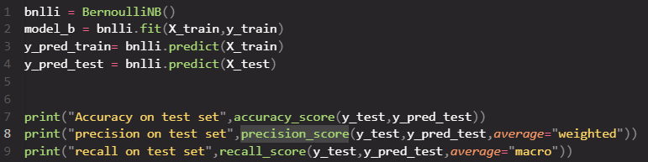

Accuracy, precision ,recall are mention below

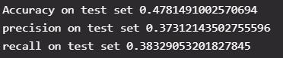

*Gaussian Naïve Bayes*

*Code:*

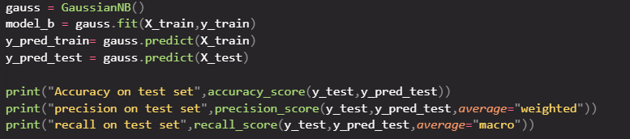

Accuracy, precision ,recall are mention below

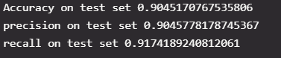

Result: The accuracy, precision and recall of *Gaussian Naïve Bayes*

Far more than *Bernoulli Naïve Bayes*

PART :**E**

Use Principal Component Analysis (PCA) to reduce the number of features and use the reduced data set for model training.

Code:

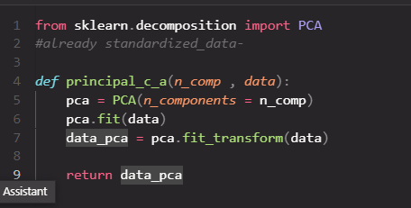

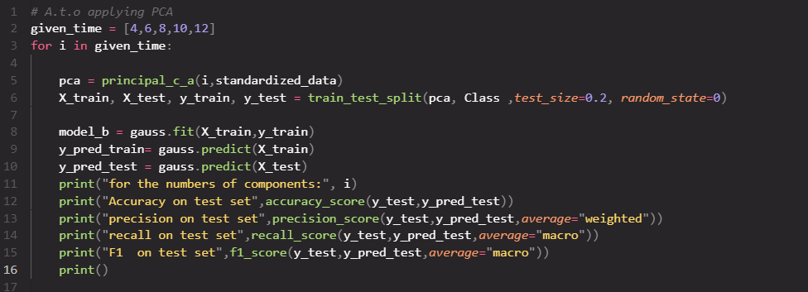

*for the numbers of components outputs:*

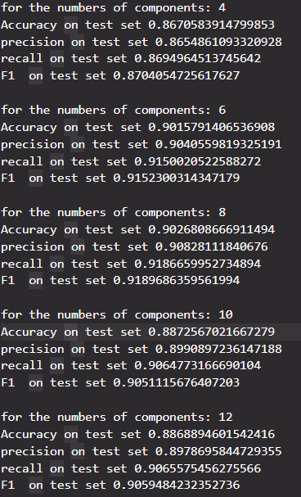

PART :**G**

using Sklearn’s implementation of Logistic Regression,choose appropriate parameters

Code: 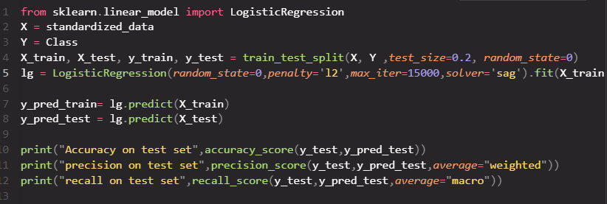

Output:

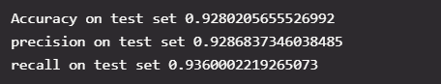

1. I have taken L2 penality so that model don’t overfit
2. I have taken solver – “sag” because given data is multiclass classification. In multiclass classification only 4 solver available. Both “sag” and “saga” are best for normalized data and our data used here are normalized one only
3. Max_iter = 15000 because after numbers of trials we get best value for this

Result : The result of Logistic Regression far more better than Naive Bayes models.